Newsletter April 2024

Save the Date: Our Annual Parish Meeting will be held on Thursday 16th May at France Lynch Church Room at 7pm. More details to follow.

Mini Food Bank at the Parish Centre – as you may be aware, we have a table in the Parish Centre, which is usually full of dry goods and household products that residents can help themselves to. This is a valuable resource, and it is used on a daily basis. However, our stocks are now depleted. We would be very grateful of any donations of goods such as rice, pasta, tinned products, pasta sauce, tea, coffee, long-life milk, breakfast cereal, jam, squash etc. If you are able to donate any items then please drop them into the office, which is open Monday to Thursday 10am until 3pm.

Friday Lunch Club –at the Frith Youth Centre every Friday 12 – 2pm. A lovely home-made soup, bread, cheese and biscuits, tea, coffee and cake all await you! This is a lovely social event, and it is a great way to meet new people. If you would like to volunteer then please get in touch.

Footpaths - New kissing gate installed
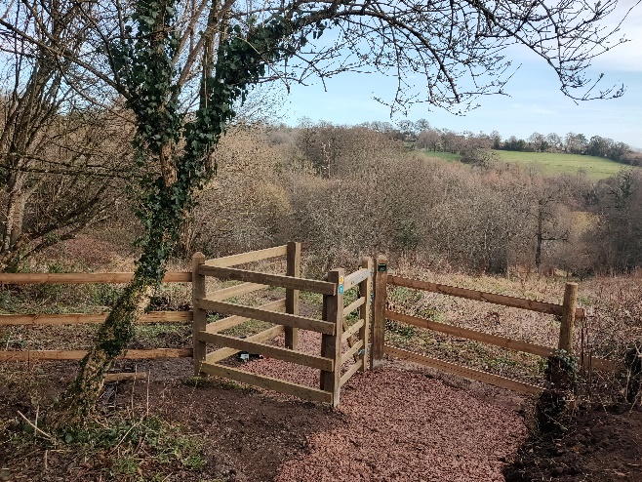
Chalford Parish Footpath Volunteers have replaced an awkward stile with a wooden kissing gate at the top of the path down to Strawberry Banks from France Lynch. Now you can walk all the way from France Lynch to Oakridge or through Three Groves Wood to the road along the Golden Valley without having to clamber over a stile.
Strawberry Banks is a nature reserve owned by Gloucestershire Wildlife Trust and is part of the Golden Valley Way. The Strawberry Banks name is thought to come from the banks having once been used to grow strawberries.

Our contact details are Chalford Parish Centre, 50 Geralds Way, Chalford, Stroud, Gl6 8FJ. (01453) 887204 info@chalford-glos.gov.uk Please contact us if you have any questions, concerns or suggestions.

