**July Newsletter**

**D-Day Celebrations** **-** We would like to say thank you to everyone who came to the D-Day 80th Anniversary event which was hosted by [Chalford Sports & Social Club](https://www.facebook.com/chalfordsportsandsocialclub?__cft__%5b0%5d=AZW2gE1WZGpxEWGxaRltLqWUMwYi0vgxn45SZFD7f2uSn-UavOZKX6NSp3nwDVYDhIfDmFkgpQKaJV3_Iui934Fr7UOUswPOoF3LFBLnEylYLIxmFI2cC6vX-f6uZoU2t8WHgPOwikWXymt4Xmy73HbmCUQrH2DGLuGCzAhyVfxvGLJo-yR6gpd-O6OcTpSb64l0IHnZZCjkpneJM4SRPPEdxf02bbL3CePI2BecbhJ23HzyRNjjUKWYHr4CqHy4tvs&__tn__=-%5dK-R) . Organisers did us and the community proud, they put on a wonderful event which was enjoyed by many. With musical performances from Tops & Bottoms and the Chalford Silver Band, there was varied entertainment plus some fabulous fish and chips from Bjorn Merrett. Finally a beacon was lit, following a lovely speech from Chairman Emma Trinder.

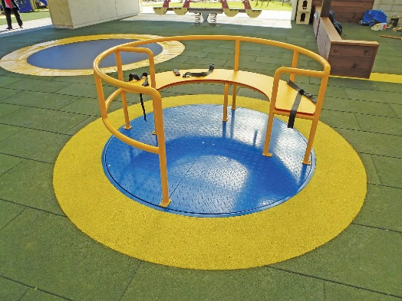**Bussage Pleasure Ground Play Equipment & Fencing Project -** We have a vision of creating a play space for young children within our existing play area at Bussage. The area will be securely fenced and will contain a variety of interesting play equipment, we will ensure that this area is inclusive and accessible to all.

We are actively seeking grants to help fund this wonderful project.

**Annual Meeting of the Parish -** Chalford Parish Council would like to thank everyone for coming to the Annual Meeting of the Parish, which was very well attended. The theme was the future of our Parish, and we were treated to excellent presentations by children from Bussage and Chalford Hill Primary Schools. We also heard from the Frith Youth Centre and SDC Cubed Youth Forum. Drinks and nibbles were very well received afterwards!

**Improving Accessibility -** Your Footpath Volunteers have installed a chicane at the bottom of the well-used path beside Frith Wood where it joins The Frith. The dimensions of the chicane match those at the top of the path so that a mobility scooter starting at the top will be able to get out. Volunteers Neil, Steve and Chris are pictured after a productive session.

**Finally** – please can people pick up their dog mess! Also, parking on grass areas instead of the road is strongly discouraged.