June Newsletter
Parish Council Elections - Our Parish Council Elections were ‘Uncontested’, so our Parish Councillors have stayed the same. The Hill Ward Councillors are Steve Beioley, Chris Gardiner, Stephen Lee, Alastair Pearson, and David Wood. Bussage Ward Councillors are Peter Funnell, Peter Oakley, Sharon Samaroo, David Taylor, Leonard Taylor and Emma Trinder (Chair). Valley Ward Councillors are Andrew Morris-Wyatt and Mike Roberts. Details of their individual areas of responsibility are published on the website.
Old Neighbourhood and Other Road Repairs – We are receiving many concerns about potholes, particularly the poor condition of Old Neighbourhood. We have been assured by Highways that this road is on their rolling programme of major repair works, however, we don’t yet have a confirmed date for the works to be carried out. We share your concerns and plan to submit further questions to Gloucestershire County Council to get clarification on the outcome of recent trials of different repair materials and methods, secure a fixed timescale for the resurfacing of The Old Neighbourhood, and establish whether any other roads in the Parish have been identified for major repairs. In the meantime, please use www.fixmystreet.com to report road defects and other concerns, the more reports that are received the higher they will be prioritised by Highways.
Neighbourhood Centre Foliage and drainage – We get asked about this area a lot and we have been working hard behind the scenes along with the Manager at Tesco Express and our County Cllr Chloe Turner to ensure that the foliage is cut back to create more space on the pavement and avoid injury from the pyracantha. We are pleased to say that after almost a year, this work has now been carried out by the Management Company who are responsible for this area, SEP Properties. We continue to pursue remedial work to the drains to address problems with the car park flooding.
Community Speedwatch Group – The main role of the Community Speed Watch Group is to monitor speed within the parish and then try to moderate the behaviour of motorists. We work closely with the local police as well as the Gloucestershire Police Road Safety unit together with GCC Highways. We need more volunteers to join our Community Speedwatch Group. If you would like to be involved, then please contact Lucy@chalford-glos.gov.uk to find out more about what is involved.
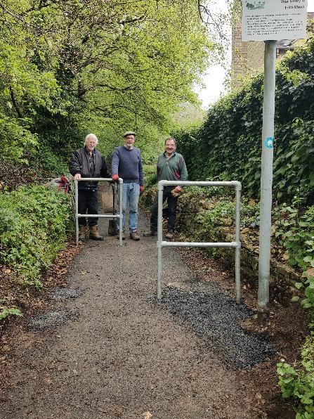
Chicane installed on well-used path
Your Footpath Volunteers have installed a chicane at the bottom of the well-used path beside Frith Wood where it joins The Frith. The chicane replaces a motorcycle inhibitor which was too narrow for some large mobility scooters. The dimensions of the chicane match those at the top of the path so that a mobility scooter starting at the top will be able to get out. Volunteers Neil, Steve and Chris are pictured after a productive session.

