November 2026

Support for our Food Bank
A huge thank you to Bussage Primary School and Chalford Hill School for their incredibly generous donations to our food bank table. We help many people in the parish who are struggling a little with the cost of living, and they have really benefited from your generosity.
The Parish Council office in Chalford continues to run a small food bank to support local residents in need. Donations for this very worthwhile cause are always greatly appreciated. If you are able to contribute, your support would make a real difference to members of our community

Santa is Coming to Chalford on Thurs 17th December between 3.15 & 5.00pm
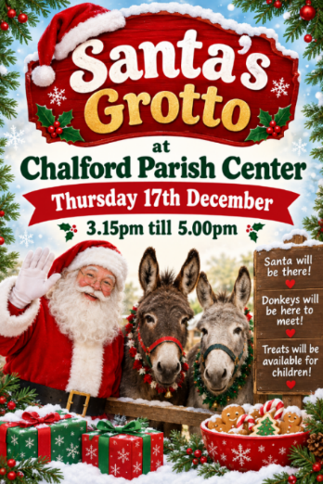
Following the success last year of having a Santa’s Grotto at the Parish Centre, the Parish Council Office Elves are organising a return visit this year! Open to all, Santa will be here to speak to you about your Christmas lists, and good little ones may be rewarded with a treat! We will be joined by some special guests too!

Longstanding Councillor Steps Down
After over 11 years of service to Chalford Parish, Councillor Peter Oakley is stepping down. We want to thank him for his incredible dedication, wisdom, kindness and integrity. We will all miss him greatly.

