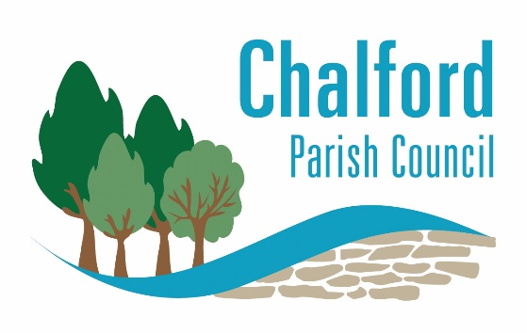

The Parish Centre, 50 Gerald's Way, Chalford, Stroud, Gloucestershire GL6 8FJ

Donations for Ukrainian Refugees

We are collecting items on behalf of the Ukrainian Catholic Church in Gloucester.

Donations can be taken to the Parish Centre, 50 Geralds way from 9am to 3.30pm until Wednesday 16th March (the office is closed on Fridays).

Please note the items that can be donated as it is very specific, no other items can be accepted.

Dry food, pasta, rice etc
Tinned food
Sleeping bags
Camping ground mats
Camping stoves & metal camping cups
Tin openers
First aid supplies such as plasters, sudocream, bandages.
Medication such as paracetamol, ibruprofen.
Clingfilm
Adult gloves
Thermal underwear
Batteries - AA, AAA etc.
Hand held torches and head torches
Toiletries

Many thanks

