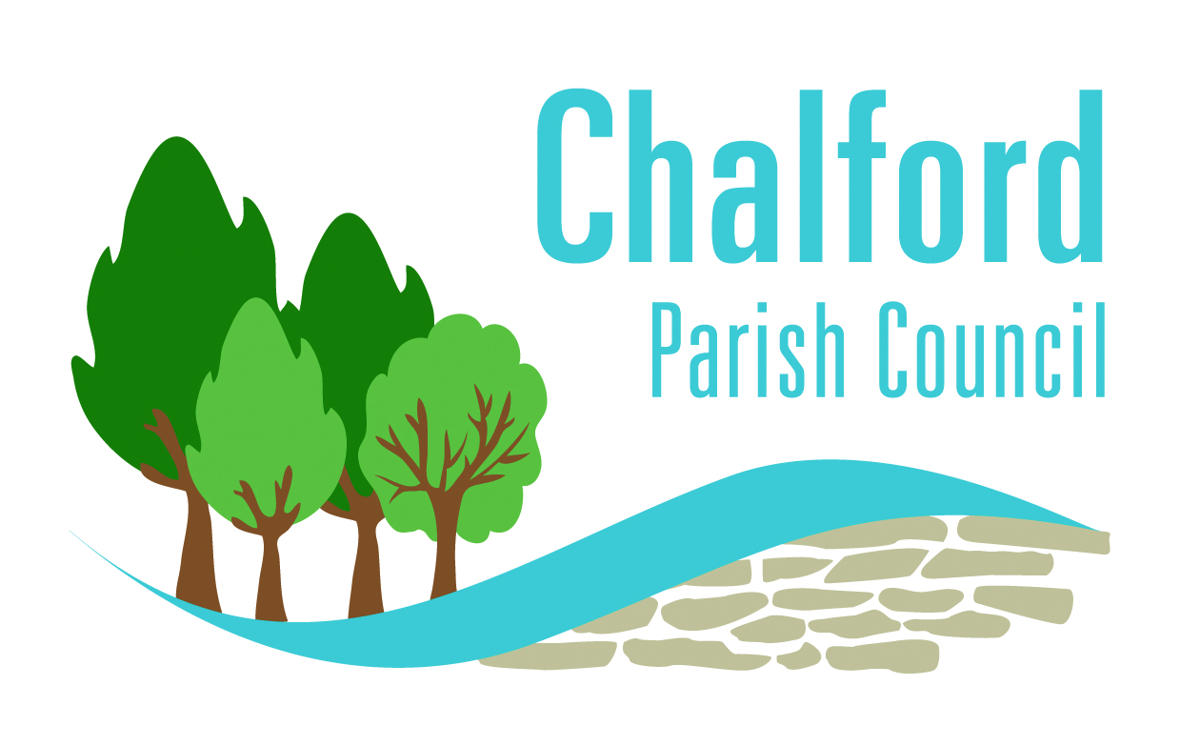
The Parish Centre, 50 Gerald's Way, Chalford, Stroud, Gloucestershire GL6 8FJ
T: 01453 887204
E: info@chalford-glos.gov.uk
W: www.chalford-glos.gov.uk

NOTICE OF MEETING

COUNCILLORS ARE SUMMONDED TO A MEETING OF THE COUNCIL

AT 7.00 P.M. ON THURSDAY, 2 MARCH 2023 AT THE PARISH CENTRE, GERALD’S WAY

BUSINESS TO BE CONDUCTED

1. To receive apologies for absence.
2. To hear any statements or submissions from members of the public
3. To receive Declarations of Interest in items on the agenda.

4. To approve the Minutes of the meeting held on 2 February 2023.

5. To receive reports on issues affecting Chalford from:

a. County Councillors b. District Councillors

6. To receive the Clerk’s report

7. To consider the SDC Parish and Town Council Charter and agree how to proceed.

8. Civility and Respect Pledge – to agree to sign up to the pledge.

9. Grants – to consider Finance and Management’s recommendations for awards.

10. Parish Centre staffing – to consider Finance and Management’s recommendations and agree how to
proceed.

11. Code of Conduct – to adopt the attached Code of Members’ Conduct.

12. To receive Cllr Funnell’s resignation and agree to advertise the vacancy.

13. SID – to respond to a resident’s request to position SID from Randalls Green to Coppice Hill.

14. Annual Meeting of the Parish – to agree a theme and date.

15. To receive any referrals from Committees.

16. To receive a report from Committee Chairmen and external meeting attendees.

17. To authorise expenditure.

18. To note and comment on general items of correspondence received.

19. To note any items for information or referral only.

Under this heading, Councillors can raise a topic, for information only, but must notify the Clerk of their intention to do so and the subject matter prior to the Meeting. (No matter will be discussed unless prior notice is given.)

…………………………………………………………
C PRINCE – CLERK TO THE COUNCIL

Members of the public are welcome to join the meeting. Please contact the Clerk.
Date of Issue: 22.2.23

